

**MATHEMATICS  
APPLICATIONS**

**Test 3 – Recurrence Relationships**

**Chapter 4**

**Semester 1 2017**

# 

**Section Two - Calculator Assumed**

Time allowed for this section

Working time for this section: 35 minutes

Marks available: 38 marks

## Material required/recommended for this section

##### To be provided by the supervisor

This Question/Answer booklet

Formula sheet

##### To be provided by the candidate

Standard items: pens, pencils, pencil sharpener, eraser, correction fluid, ruler, highlighters

Special items: drawing instruments, templates, notes on one unfolded sheet of A4 paper, and up to three calculators satisfying the conditions set by the Curriculum Council for this course.

## Important note to candidates

No other items may be used in this section of the examination. It is **your** responsibility to ensure that you do not have any unauthorised notes or other items of a non-personal nature in the examination room. If you have any unauthorised material with you, hand it to the supervisor **before** reading any further.

1. (2 marks)

Write down the first five terms of the sequence defined by the recurrence relation:



1. (2 marks)  
     
   The nth term of an arithmetic sequence is given by the rule:



Determine the recurrence relation.

1. (7 marks)  
     
   A lump sum of money is invested in a savings fund that compounds interest annually.  
   The amount of money in the savings fund,  , is given by the recursive rule  , where  and *n* is the number of years after the initial deposit.
   1. State the initial amount of the lump sum. [1]
   2. State the annual interest rate offered by the savings fund. [1]
   3. Explain why the multiplication factor is 1.05 [1]
   4. Determine
      1. the amount of money, to the nearest cent, in the savings fund after four years. [2]
      2. the amount of interest earned during the first year. [1]
      3. the amount of interest accumulated during the first four years. [1]
2. (8 marks)  
     
   A plant grew from a seed to a height of 120 cm in its first year. The growth of the plant in subsequent years is expected to be 60% of its growth in the previous year.
3. Determine
4. The growth of the plant during the second year. [1]
5. The height of the plant after two years. [1]

The growth of the plant during the nth year can be given by , where .

1. Complete the growth table below. [2]

|  |  |  |  |  |  |
| --- | --- | --- | --- | --- | --- |
| Year | 1 | 2 | 3 | 4 | 5 |
| Growth (cm) | 120 |  |  |  |  |

1. Plot the annual growth of the plant on the axes below for the first five years. [2]

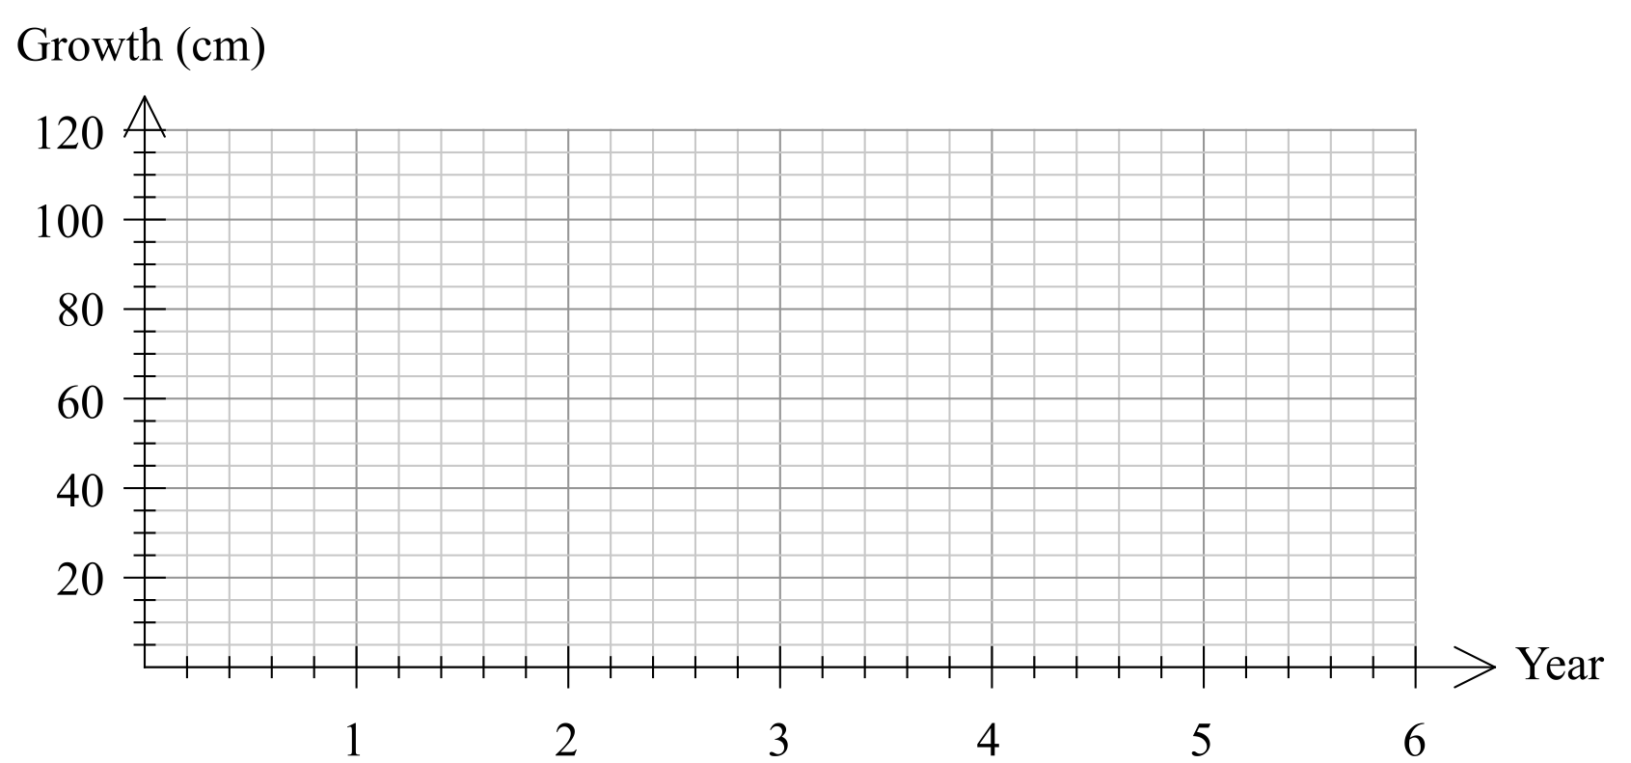

1. In which year is the growth of the tree first less than 1 cm? [1]
2. Describe height of the tree in the long-term. [1]
3. (9 marks)  
     
   A fish farm is stocked with 5000 fish. The owners plan to sell 25% of the fish stock throughout the year and then to re-stock the farm with an extra 300 fish at the end of the year. The fish stock,  , at the start of year *n* can be modelled by , where .
4. Explain the significance of the 0.75 in the model. [1]
5. Complete the table below for the first 8 years, **rounding values to the nearest ten**. [2]

|  |  |  |  |  |  |  |  |  |  |
| --- | --- | --- | --- | --- | --- | --- | --- | --- | --- |
| *n* | 0 | 1 | 2 | 3 | 4 | 5 | 6 | 7 | 8 |
|  | 5000 |  |  |  |  |  |  |  |  |

1. Graph the fish stock at the start of the first 8 years on the axes below. [3]

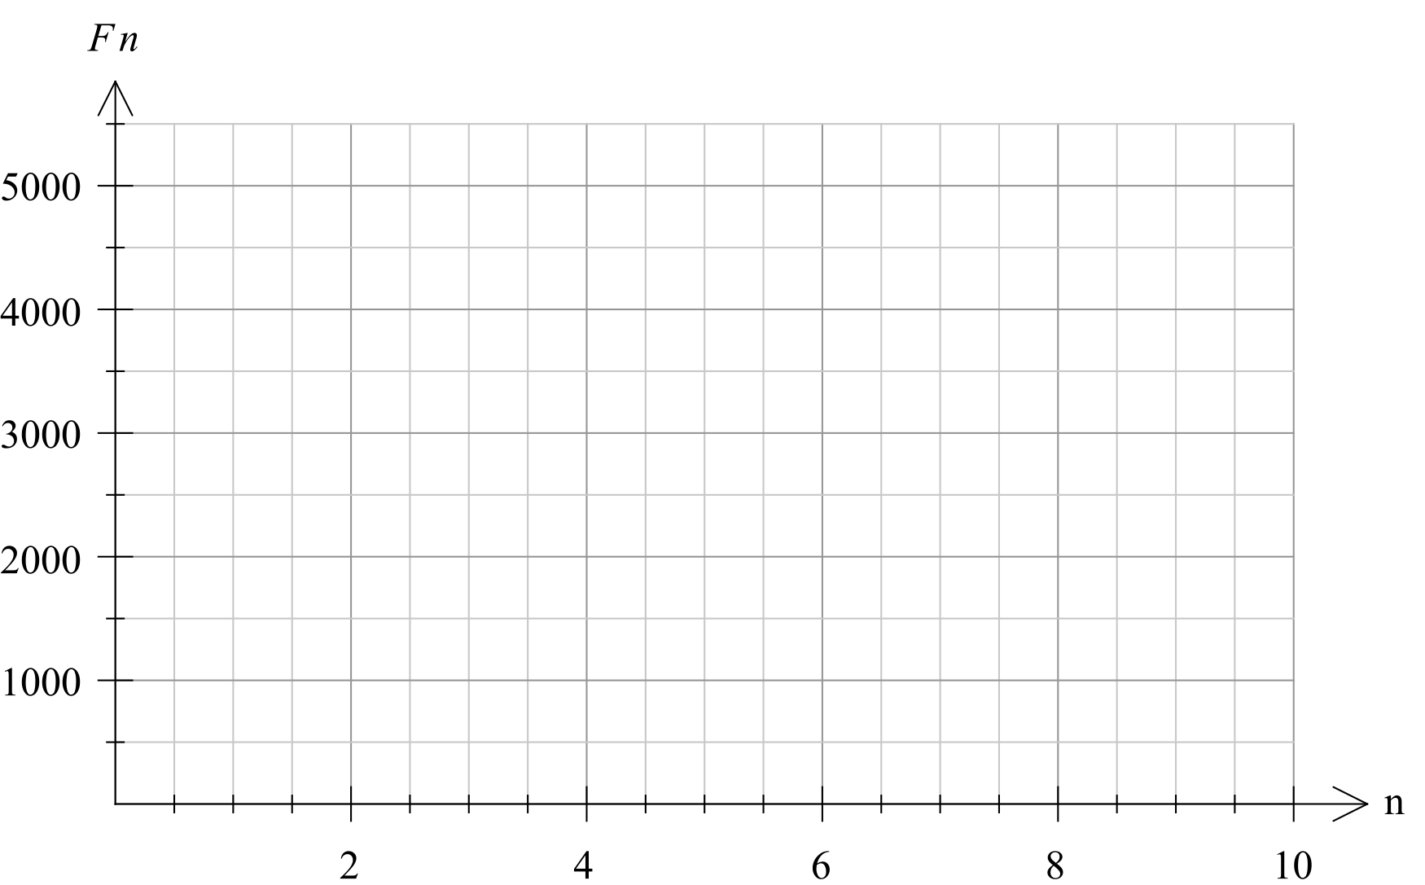

1. Comment on how the size of the fish stock is changing over the first 8 years. [1]
2. Calculate the expected fish stock after 20 years, and comment on the long-term size of the fish stock according to this model. [2]
3. (10 marks)  
     
   A study of the population of a rare marsupial found the population growth rate was 9.5% per annum. At the commencement of the study (at the start of 1997) the population was 2000.
   1. Write a recursive formula for predicting the population, P, *t* years after 1997. [2]
   2. Predict the population at the start of 2007 (to the nearest whole number). [2]
   3. Show clearly that the population t years after 1997 can also be written as  where A and *b* are constants. State the values of A and *b*. [3]
   4. Predict when the population first exceeds 10 000. Show clearly how you obtained your answer. [3]

Extra space for working if required

**End of Test**